**WebTracker Chrome**



**Installation Guide**

*Adding WebTracker to Chrome*

* Begin by visiting: <https://chrome.google.com/webstore/detail/web-tracker/meggficlncdkcefnkpgbihhldbhfbell?authuser=1>

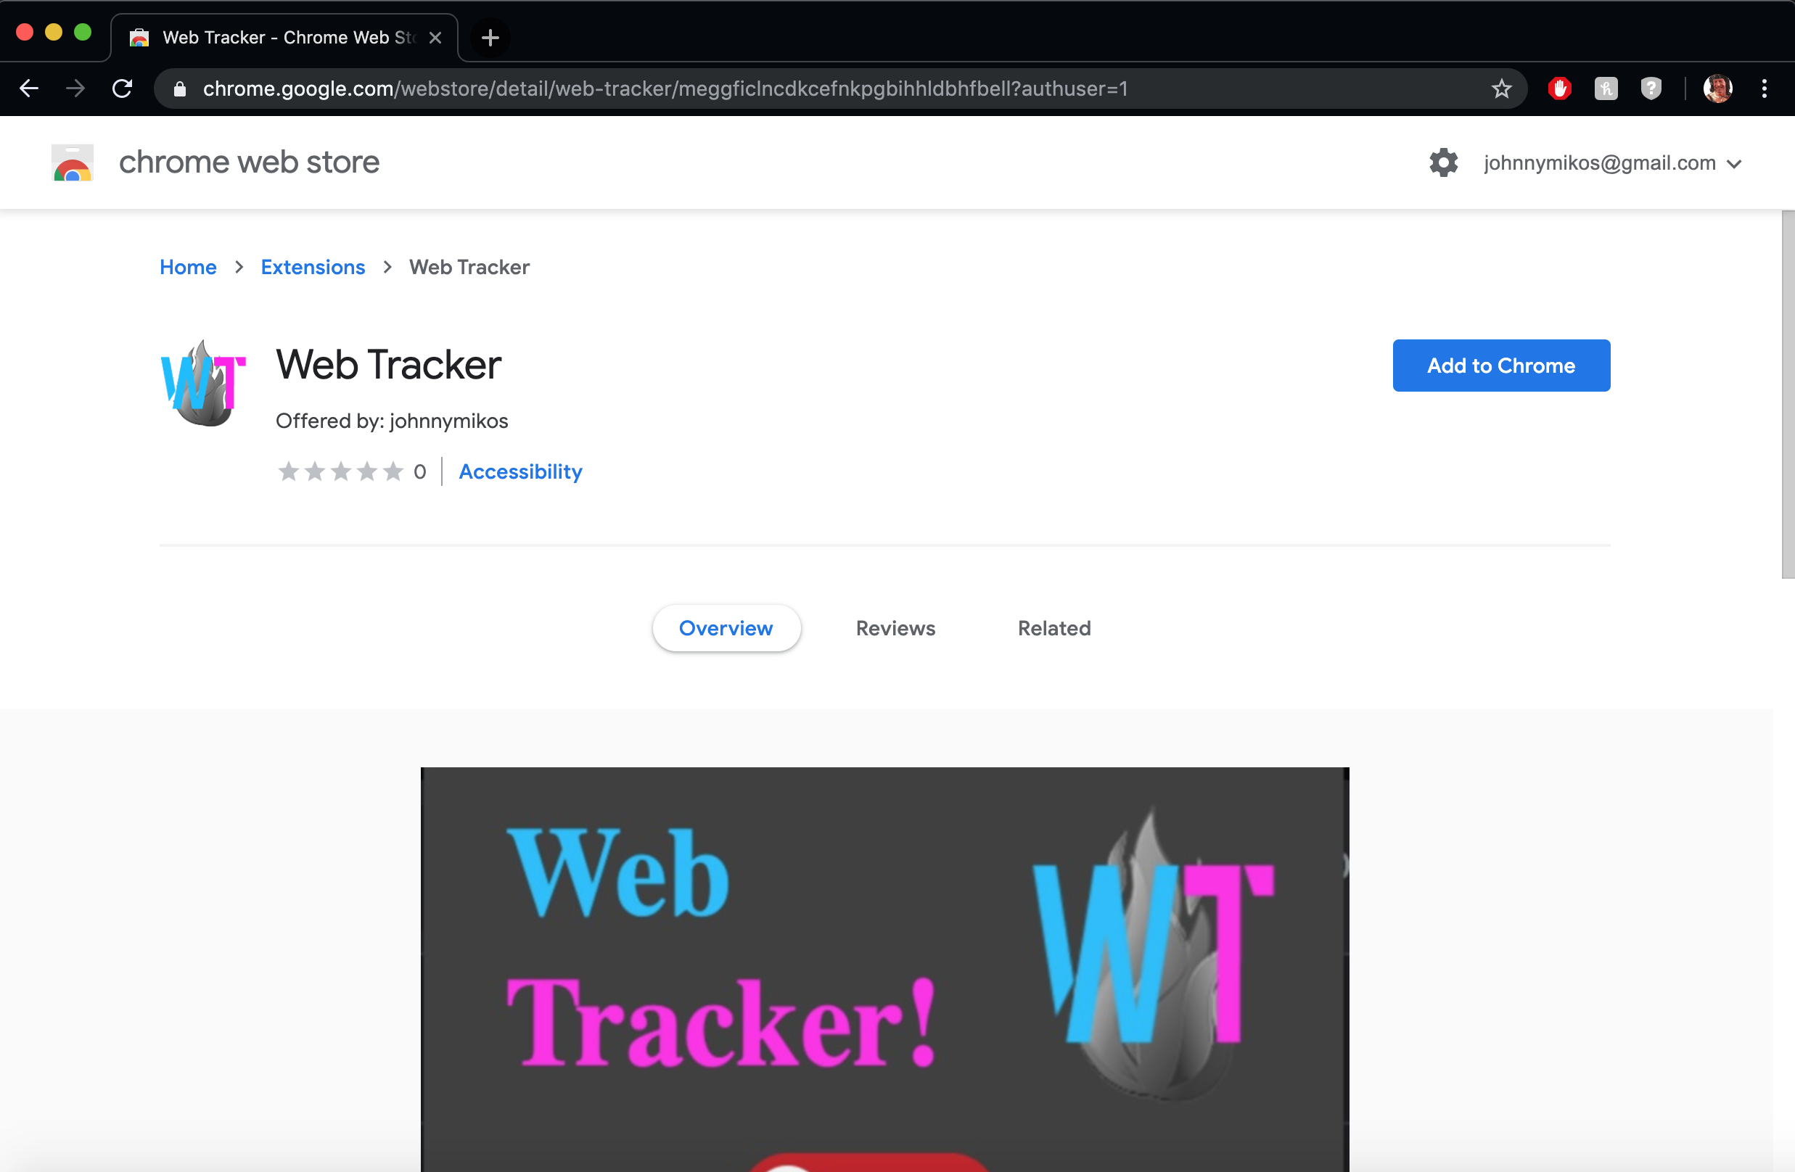

* Now click “**Add to Chrome**”
* Then click “**Add Extension**” when this popup appears

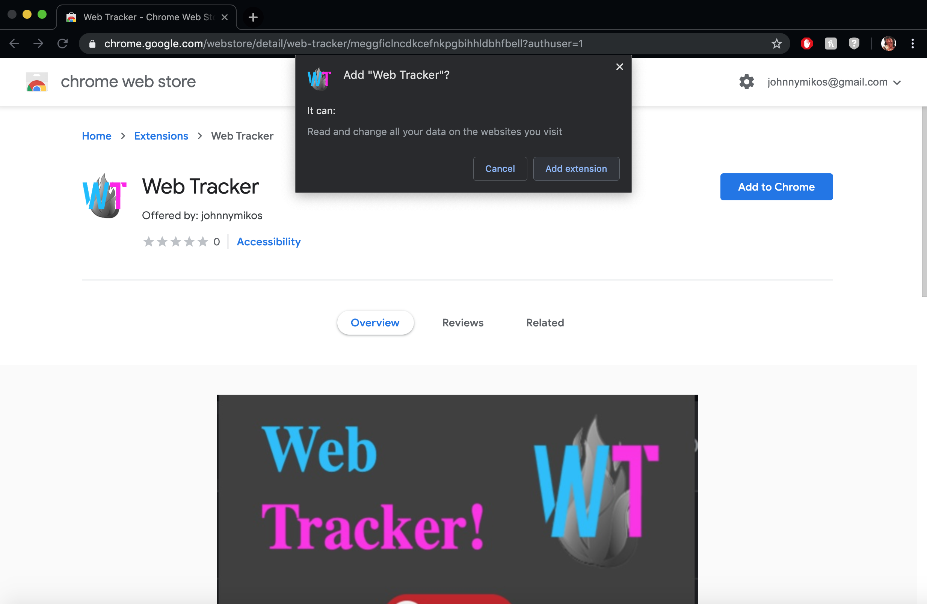

* It has successfully been added if you see this popup appear

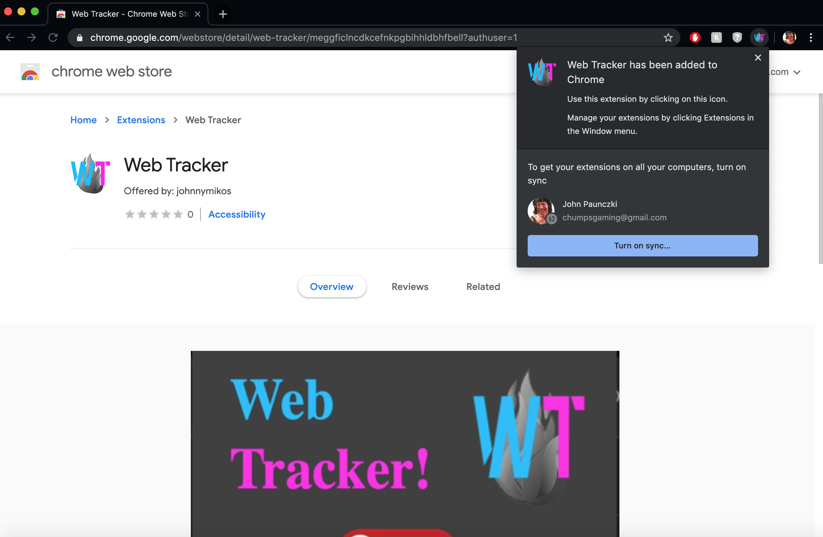

* Continue by opening a new tab and typing in “**chrome://extensions**”

From here you will be able to turn off/on or remove extensions

(may need to scroll down to find WebTracker)

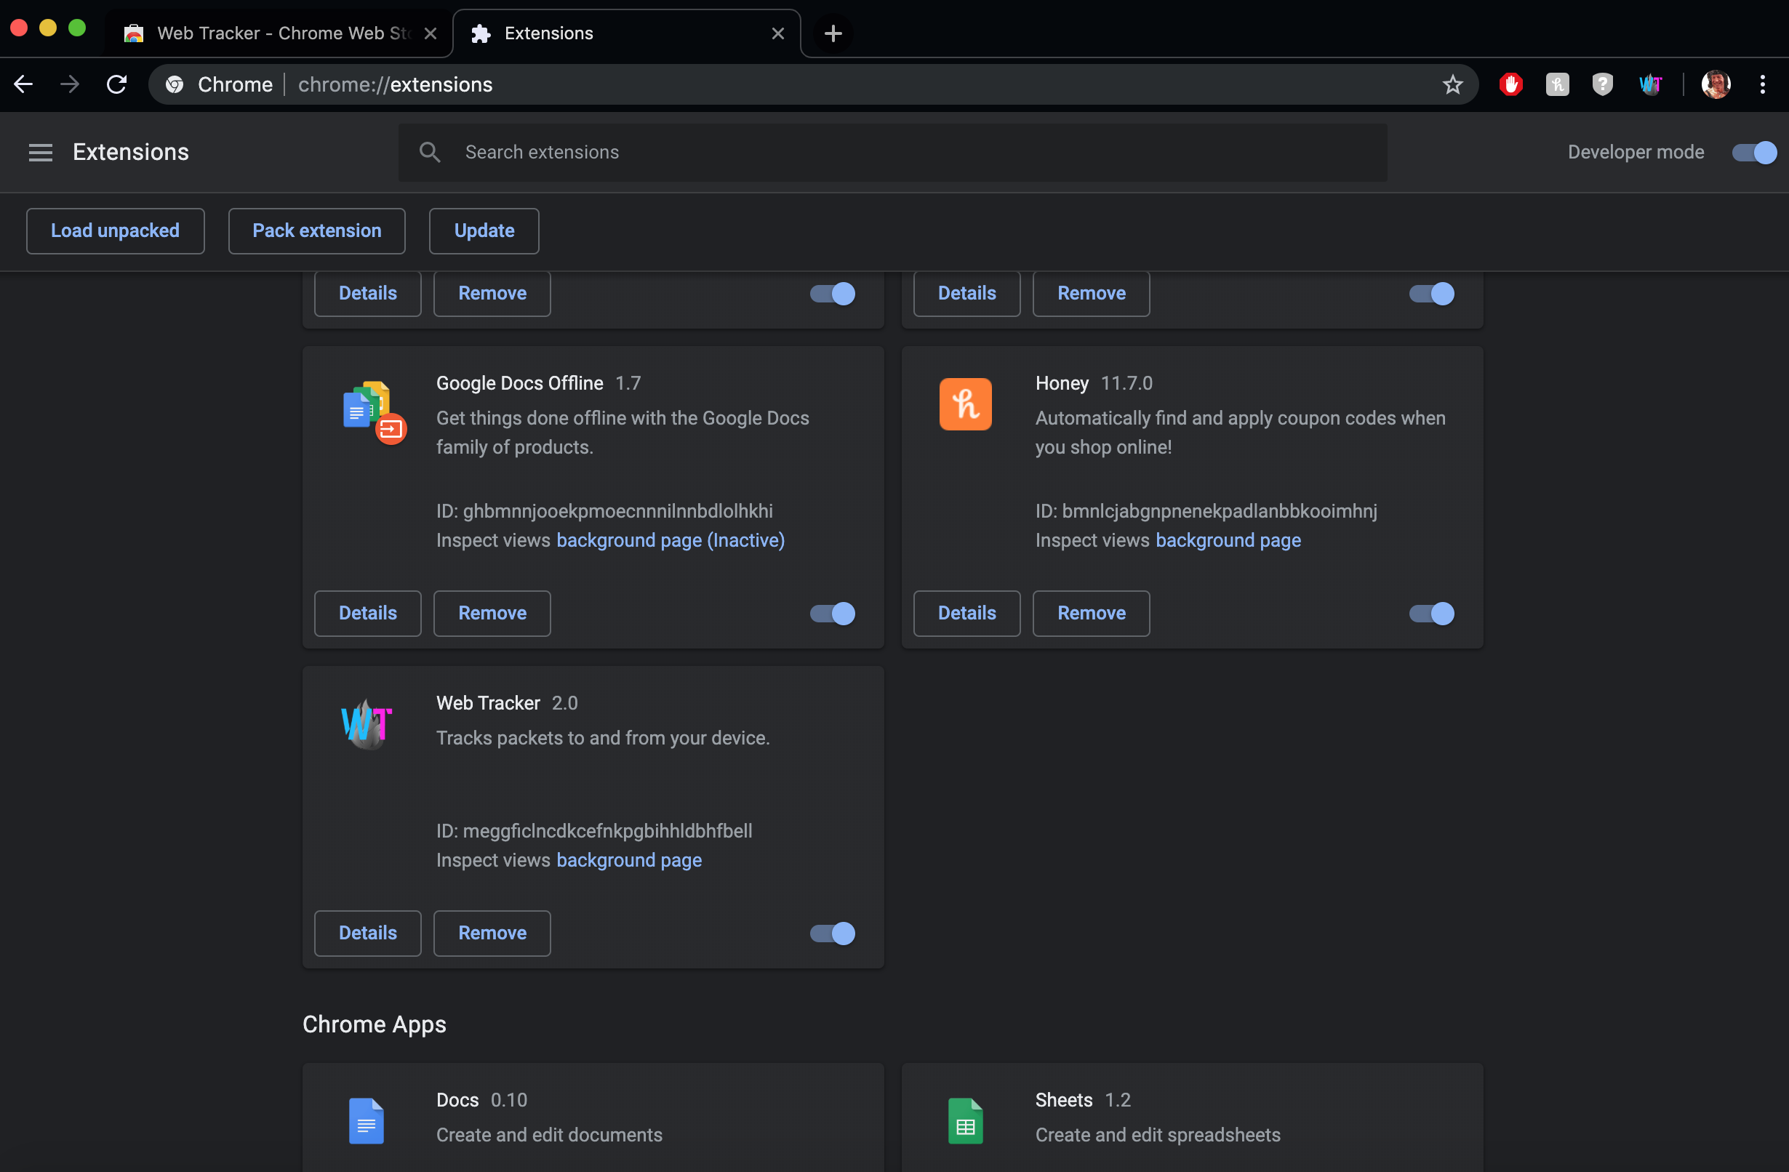

* You have successfully installed the extension

*Using WebTracker*

* To use WebTracker click the popup at the top to open the popup menu

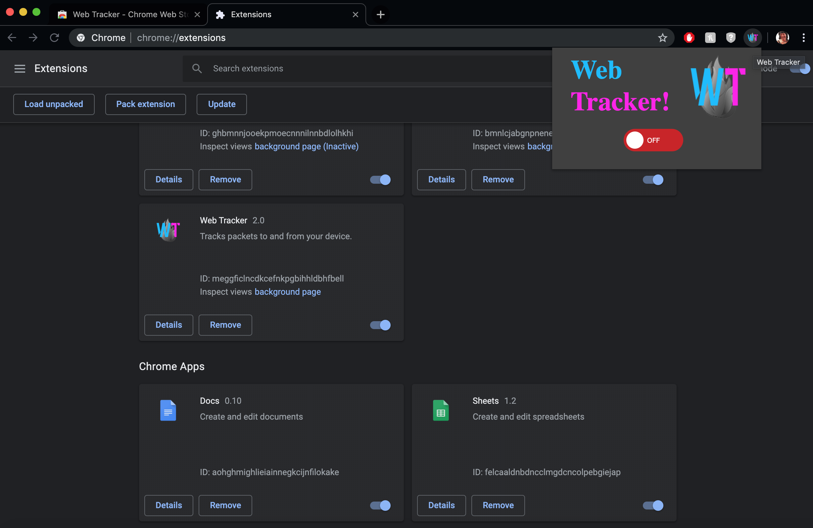

* The only functional part is the on/off switch, it dictates if WebTracker is sending your information or not



* The conditionals are as follows…
  + If the switch is **green**, switched to “**ON**”, and the icon is in color, your browsing information is being sent to the server.

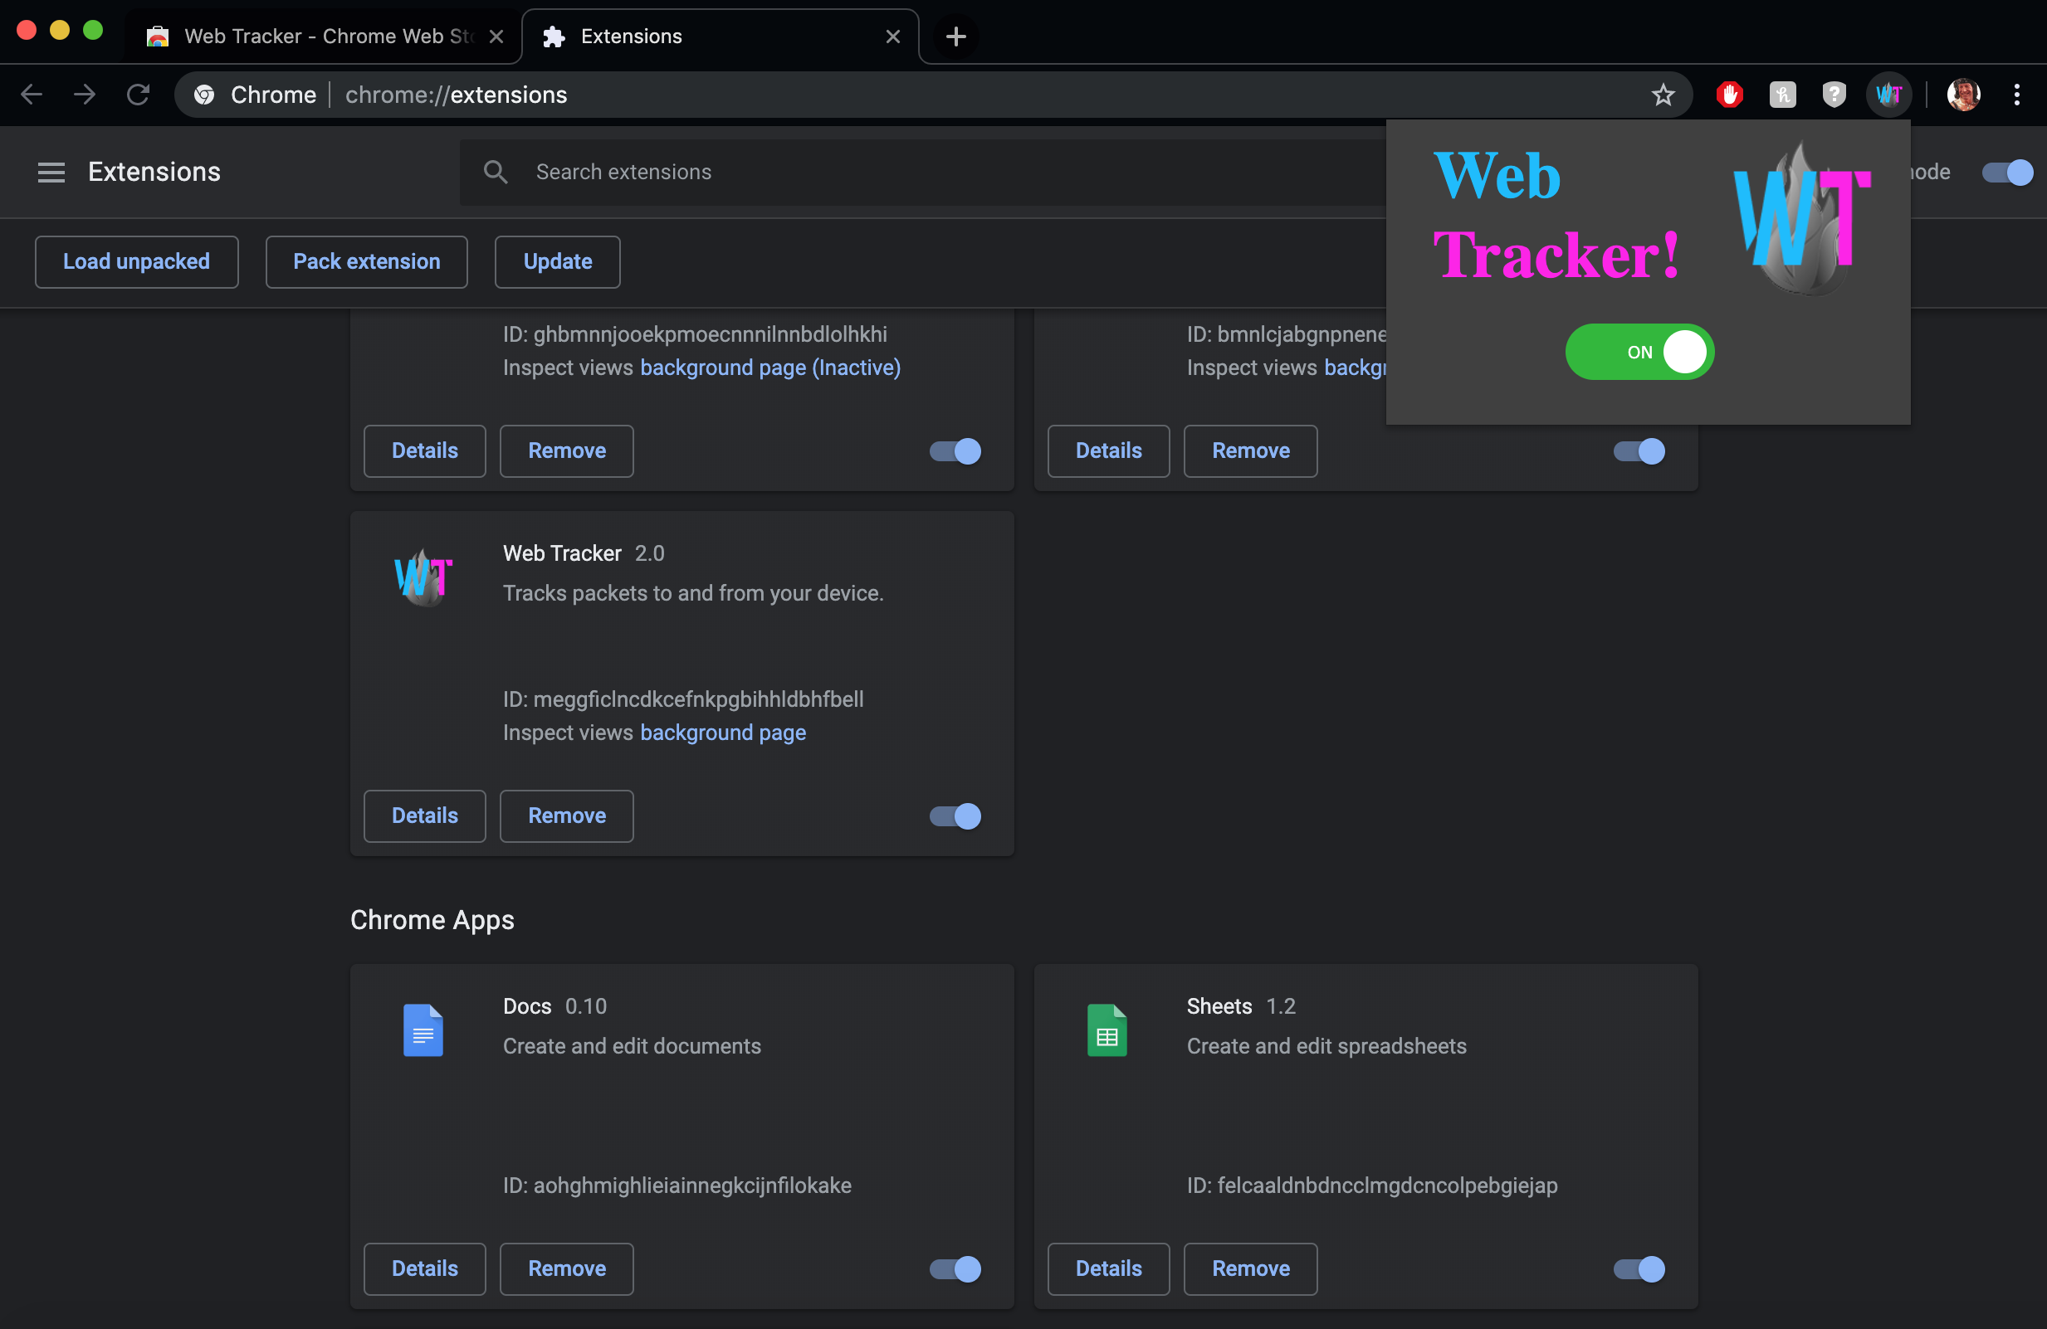

* + If the switch is **red**, switched to “**OFF**”, and the icon is grayed out, none of your browsing information is being sent to the server.

*Note*: when WebTracker is first installed it will be colored in to show it is present.

It will not be sending any of your information. The first time you switch

“**ON**” to “**OFF**”, the icon will finally become grayed out.

